Nov. 12th, 1999

Dear Authors:

We at the ITC-10 Editorial Office welcome all of your contributions to the conference proceedings. For your information, the instructions for manuscript preparation are attached here, together with a sample. If you have any questions, please contact us at procITC10@nifs.ac.jp.

Thank you and look forward to seeing you in Toki.

Editorial Office
Prof. A. Sagara, Chief Editor
Prof. Y. Hirooka, Secretary

Instructions for Proceedings Manuscript Preparation
(for Contributed Papers to ITC-10)

1. Introduction
All papers presented at ITC-10 will be considered, via peer review, for inclusion in the conference proceedings, a special issue of the Journal of Plasma and Fusion Research (JPFR) published by the Japan Society of Plasma Science and Nuclear Fusion Research. Details of this journal and society can be found at www.nifs.ac.jp/jspf/index-e.html. To make a timely publication of these proceedings, the Editorial Office has come up with the following instructions for manuscript preparation. Authors’ cooperation will be greatly appreciated.

2. Manuscript preparation
Language and authors: Manuscripts should be written in clear English and should bear the name(s) and full affiliation(s) of the author(s), their mailing address(es) and corresponding author’s name and e-mail address. The names of authors must appear in such a way that last name comes first in upper case and then first name follows in lower case, as shown in the attached example.
Length limit: The total length will be limited to 4 journal pages. The conference proceeding publication budget is extremely tight, so that this page limit must be observed. Authors are kindly advised to prepare 3.5-page long manuscripts, leaving room to grow in responding to reviewers’ comments.
Format: As shown in the attached example (see www.nifs.ac.jp/~itc10/paper_format.PDF or below), it is recommended that approximately 0.5 page will be used for the authors and abstract. The margin for this “cover page” is limited to 142 mm. The rest of manuscript must be prepared in the following manner. Fit your manuscript in a 76 mm x 221 mm column each page, leaving ample room for reviewers’ comments. Therefore, efforts must be made to fit figures in the column. If this is not possible, however, figures may be laid, using the whole margin of 161mm. Please note that the Editorial Office will not be able to handle any footnotes. This format will help the editorial staff to figure out easily the length of your paper upon receipt at the conference (see Manuscript submission section).
Word processor and font: Microsoft WORD version 8.0 or later is recommended. However, LaTex files can also be handled at the Editorial Office. Single space all text, which allows to fit 51lines in the column described above. Use Century-9pts font or equivalent, except for equations. Equations must be prepared using the software compatible with these word processors (see Manuscript submission section).
References: References should be included at the end of the manuscript, but within the page limit (see the attached example). They must be listed in order that they appear in the text in the following manner: [1] Y. Hirooka et al., Nucl. Fusion 32, 2029(1992), where the number in bold letters indicates the volume number, followed by the pager number and the year of publication in round brackets.
Reproduction: If manuscripts contain any reproduction from other sources, authors are requested to furnish the Editorial Office with a document of the original publisher’s agreement.
Units: Authors are requested to use the metric units in the SI form.

2. Manuscript submission
Submission for review: Bring with you to the conference and turn in your original manuscript and three copies at the publication desk. The original will be retained at the Editorial Office and the copies will be forwarded to reviewers. Upon receipt, manuscripts will be check in terms of length and format, etc. Please be advised that if these guidelines are severely violated, manuscripts will not be forwarded to reviewers, in which case these manuscripts can not be considered for inclusion in the proceedings. Again, authors’ cooperation would be appreciated from the timely publication point of view. Reviewers’ comments will be forwarded to authors as soon as they become available.
Submission for publication: Responding to reviewers’ comments, authors are requested to revise and re-submit their manuscripts to the Editorial Office, whereby the acceptance for publication will be decided. For the proceedings publication, the Editorial Office need to collect from authors revised manuscripts and also their electronic files. In preparing electronic files, both PC and Mac are acceptable. Again, equations must be prepared using the software compatible with these platforms. If they wish for simplicity, authors can provide two separate files: one for the abstract page in single column format; and the other for the text pages in double column format.

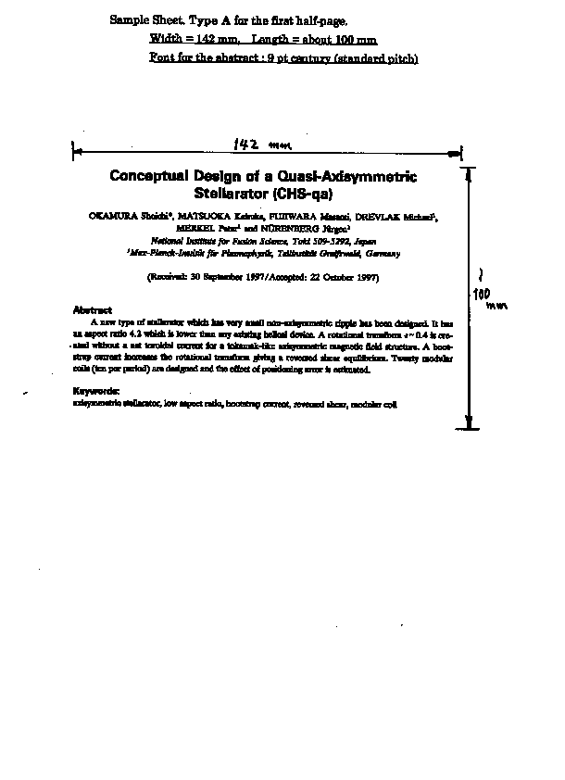
About 0.5 page

Exactly 0.5 page
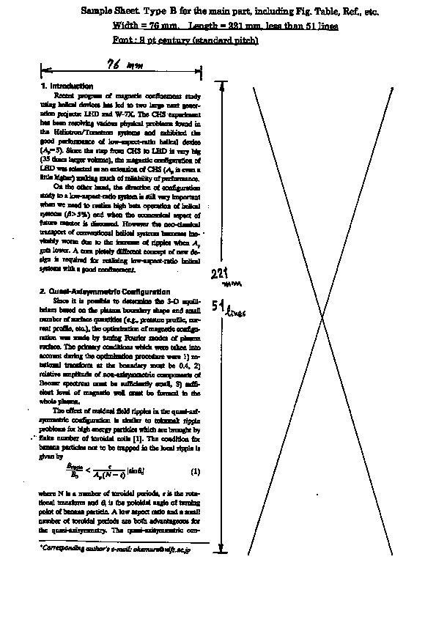
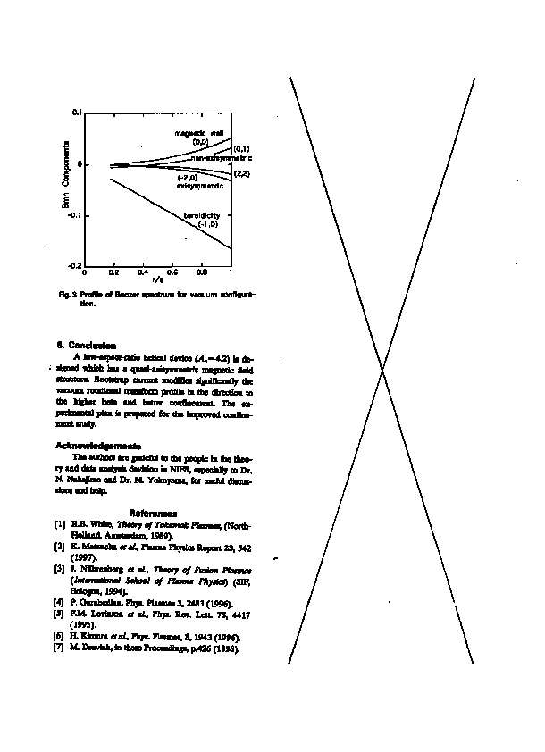

about 0.5 page
